Illustrative Mathematics
6.NS Making Hot Cocoa, Variation 1 Alignments to Content Standards

Alignment: 6.NS.A.1

Tags

- This task is not yet tagged.

One thermos of hot chocolate uses cup of cocoa powder. How many thermoses can Nelli make with 3 cups of cocoa powder?

- Solve the problem by drawing a picture.

- Explain how you can see the answer to the problem in your picture.

- Which of the following multiplication or divisions equations represents this situation? Explain your reasoning.

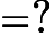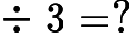

- Solve the arithmetic problem you chose in part (c) and verify that you get the same answer as you did with your picture.

Commentary

This is the first of two fraction division tasks that use similar contexts to highlight the difference between the "Number of Groups Unknown" a.k.a. "How many groups?" when the quotient is a fraction (or mixed number) greater than 1 (Variation 1) and when the quotient is a fraction that is less than 1 (Variation 2). Even when students understand this type of division context when they involve whole numbers, the transition to division problems involving fractions is not easy. In order to successfully make this transition, students must have a solid understanding of multiplication and division with whole numbers and multiplication with fractions.

These two tasks are meant as instructional tasks, with the idea that students who can solve these problems with diagrams may or may not see the connection to division. Thus, the tasks ask students to make this connection explicit.

There are significant language issues when moving from whole number to fraction division when the quotient is less than 1. In that case, it might help to point out that "Number of Groups Unknown" is better characterized as "Fraction of a Group Unknown" a.k.a. "What fraction of a group?" and the alternate of "Group Size Unknown" would be worded "How much in each group?"

Solutions

Solution: Solution

  - Below is a picture that can be used to solve the problem.

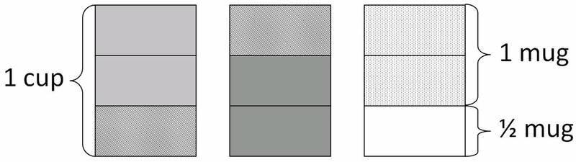

  - The picture shows three rectangles that each represent 1 thermos of cocoa powder. Each thermos is divided into thirds. Since one thermos requires cup, 2 thirds are shaded to show a single thermos of cocoa. There are four whole groups of cups of cocoa and of a group of cups of cocoa shown in the picture.

Nelli can make thermoses of cocoa.

  - We have divided the 3 cups of cocoa powder into groups of size , so we are finding out how many groups of $\frac{2}{3}$ there are in 3. So the correct equation is:

  - Solve the arithmetic problem you chose in part (c) and verify that you get the same answer as you did with your picture.

So the computation gives the same answer as we see in the picture.

6.NS Making Hot Cocoa, Variation 1 is licensed by Illustrative Mathematics under a Creative Commons Attribution-NonCommercial-ShareAlike 4.0 International License

