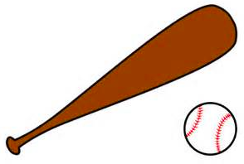
Name _____________________________ Date _________________

Batting Orders

Jimmy needs to put three batting orders from least to greatest. He writes them this way: 0.276, 0.283, and 0.279. Do you agree with Jimmy? Write your claim and consider your warrants in your answer.

