College Preparatory Mathematics Chapter 3 Sample Argumentation Task
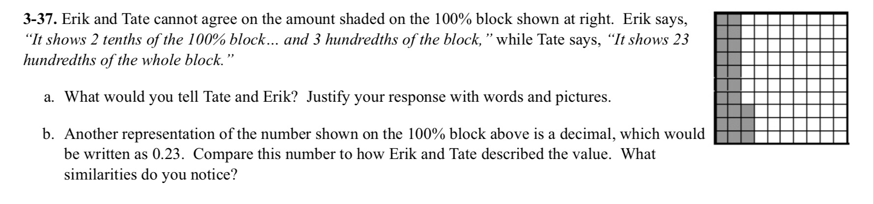
This is an ADEQUATE QUALITY argument task. We are presented with two characters with opposing views and students are asked to analyze and critique their reasoning. In our experience implementing this problem, the concept was simple for students and not a lot of time was spent on the evidence, which is why it is not high quality. However, problems like this are great to help students focus on the writing process and truly take the time to explain their reasoning.

"Erik and Tate cannot agree on the amount shaded on the 100% block shown at right. Erik says, "It shows 2 tenths of the 100% block... and 3 hundredths of the block." Tate says, "It shows 23 hundredths of the whole block." What would you say to Erik and Tate to help them settle their disagreement? Be sure to be specific, and use pictures or expressions to help them understand."

