College Preparatory Mathematics Chapter 9 Sample Argumentation Task
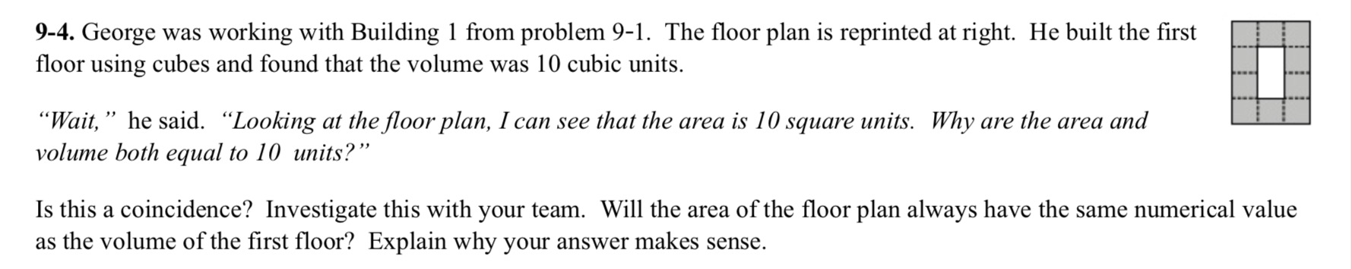
This is a HIGH QUALITY argument task. It asks students to critique the reasoning of the character as well as dispel common misconceptions and explain their answer and provides them with a visual representation to help get started with their evidence.

"George was working with building 1 from problem 9-1. The floor plan is reprinted at the right. He built the first floor using cubes and used 10 cubes. George thinks that the area of the floor plan of a building will always be equal to the volume of the first floor. Do you agree with George? Explain your reasoning and support your answer with sufficient evidence."

