College Preparatory Mathematics Chapter 1 Sample Argumentation Task
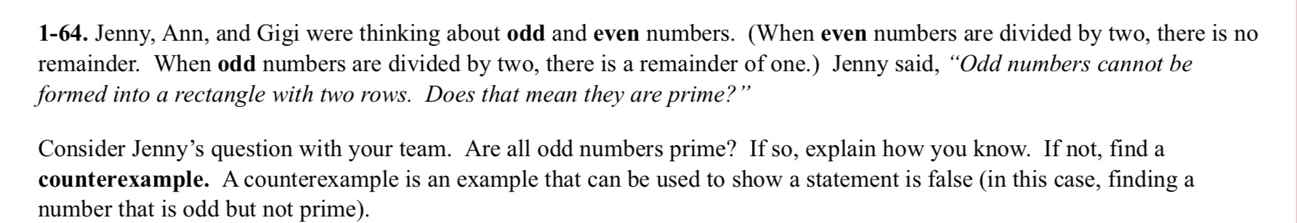
This sample is an ADEQUATE QUALITY argumentation task. We are presented with a character who has a mathematical misconception. However, the wording of this task is repetitive, and shortening it could help student reading comprehension. Also, since there are no visuals some students might have a hard time visualizing this concept, so I would be sure to provide drawing strategies or manipulatives. With these accommodations the task can lead to a great talk frame discussion regarding primality and its relationship to oddity.

"Jenny, Ann, and Gigi were thinking about odd and even numbers. Jenny said,"odd numbers cannot be represented as a rectangular pattern with two rows. Does that mean they are prime"? Do you agree with Jenny? Use labeled sketches to support your answer and explain your thinking."

