Name ______________________________________ Date _____________________

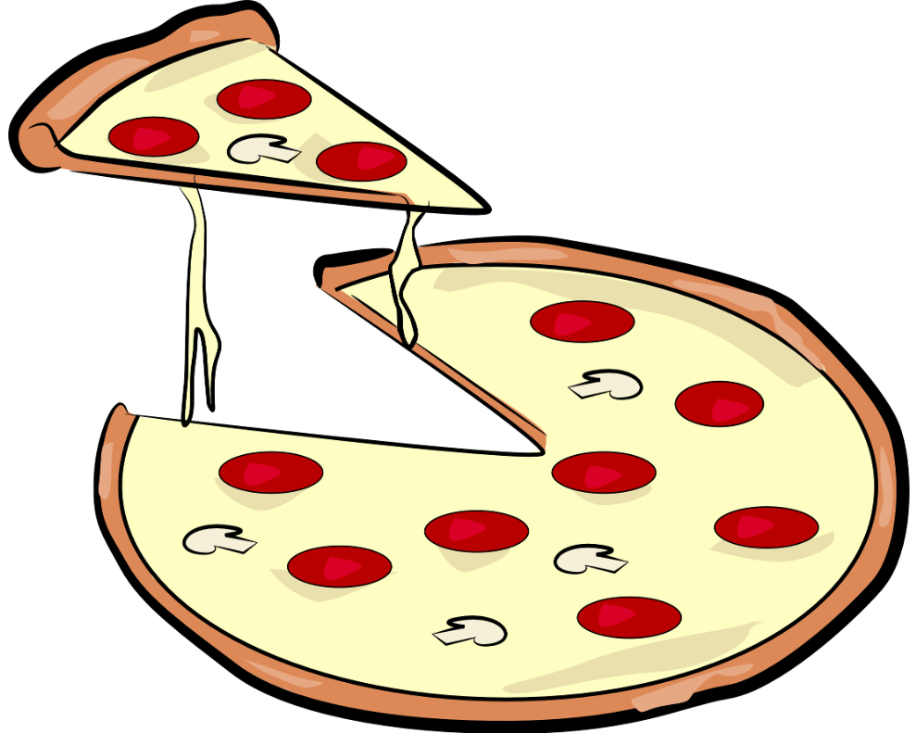

Pizza Party!

Mrs. Phelps wants to have a pizza party for her 16 students. The large pizza at Dominos has 10 slices of pizza and the medium has 8 slices. If each student gets 2 slices, Martha thinks Mrs. Phelps should order 3 large pizzas. Karen thinks Mrs. Phelps should order 4 medium pizzas. Who do you agree with? Explain your thinking.

