Name ______________________________________ Date _____________________

Same or Different?
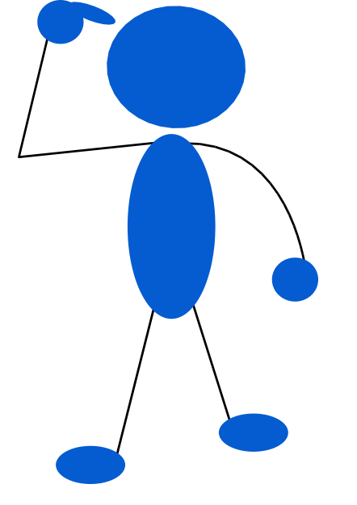

Are 2 x 6 and 6 x 2 rectangles the same or different? Explain your thinking. Be sure to include your claim, evidence and any warrants.

