Name ___________________________________ Date ________________________
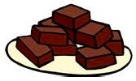
Trays of Brownies

Helen thinks if she takes 1/4 of the brownies in each tray she will have the same amount as one full tray of brownies. Who do you agree with and why? Explain your thinking.

