Name _____________________________ Date _________________
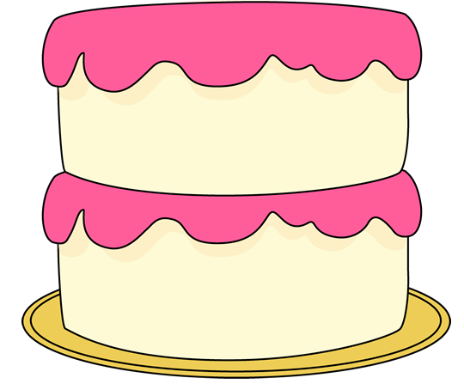
Parts of a Cake

Jenny ate ¼ of the cake. Billy ate ½ of the cake. Billy thinks he ate more cake than Jenny. Do you agree or disagree? Explain your answer and include evidence.

