Name ______________________________________ Date _____________________

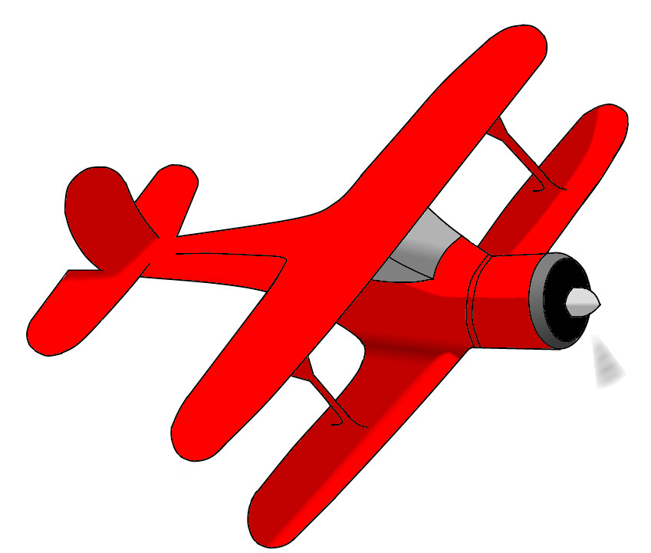

Airplanes in the Toyshop

The student’s in Miss Frizzle’s class had to do this word problem for homework: There are 700 airplanes in the toyshop. During the day, 259 of them were sold. How many toy airplanes are left in the shop?

When Matt solved the problem, he did this:
700
- 259
559

Do you agree or disagree with Matt? Tell me why by explaining your thinking.

