Name ______________________________________ Date _____________________

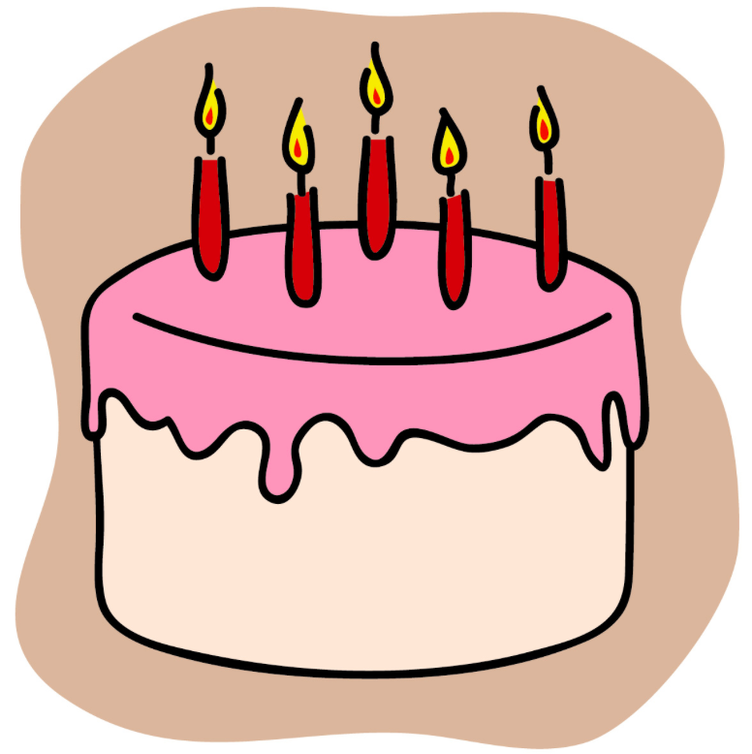

Baking a Cake

Jamie needs 6 ounces of canola to bake her cake. Her mom says that she has a $\frac{1}{2}$ cup of canola oil left in a bottle in the pantry. Does Jamie’s mom have enough canola oil for Jamie’s cake, or does Jamie need to make a trip to the grocery store to buy more? Explain your thinking.

