College Preparatory Mathematics Chapter 2 Sample Argumentation Task
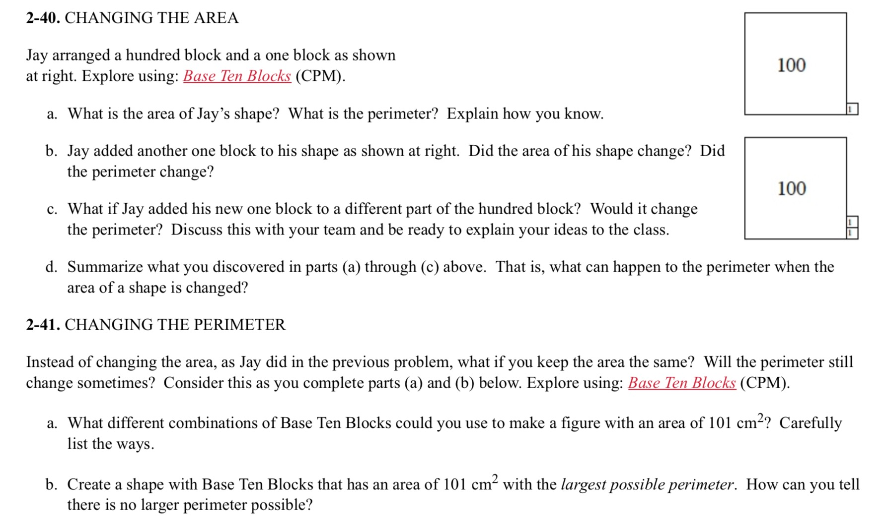

Samples 2-40 and 2-41 can be accommodated and combined to make a HIGH QUALITY argument task. The idea of adding blocks to change area of perimeter can be a more difficult concept for students and many will confuse the two. Combining 2-40 part c and the opening question in 2-41 will help address some mathematical misconceptions and drive students to use logic in their response.

"Jay arranged a hundred block and a one block as shown at the right. Jay believes that if he moves his one block to a different part of the hundred block, the perimeter of the shape would change. Do you agree with Jay's idea? Explain your reasoning."

