College Preparatory Mathematics Chapter 6 Sample Argumentation Task

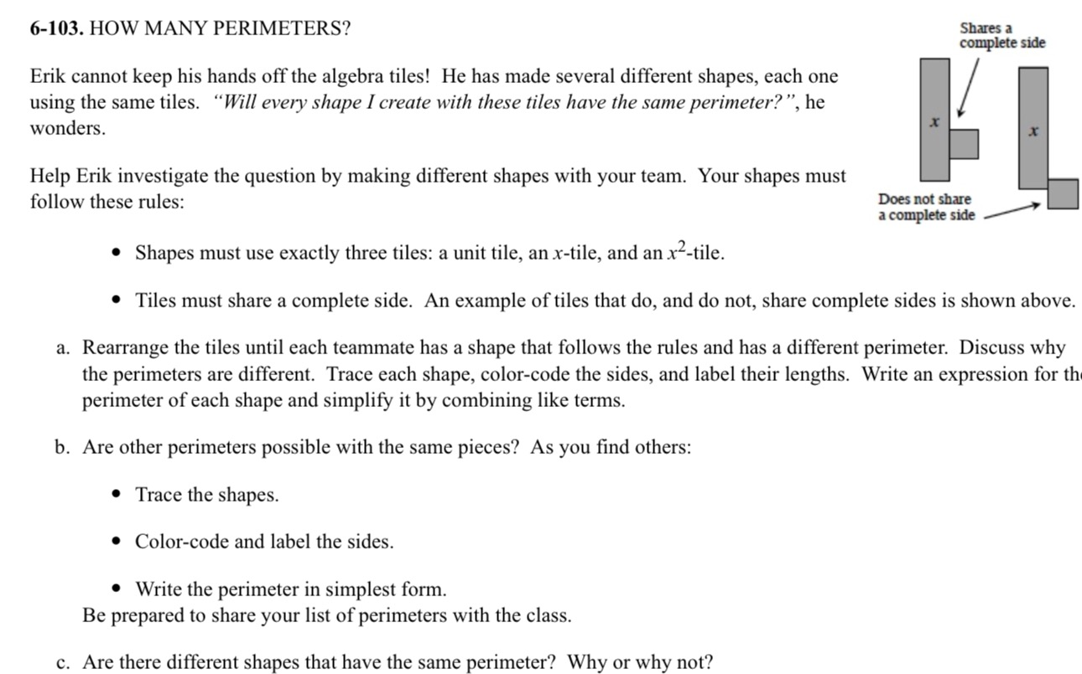

This sample is a HIGH QUALITY argument task, however, it is too lengthy and should be condensed for understanding and efficiency. The visual component and algebraic notation are helpful for students to visualize concepts and work on their divergent thinking and the question is full of why or why not questions. I would select pieces of this sample to use in an argument piece such as part c or simply Erik's claim in italics.

"Erik has made several shapes (shown at right) using algebraic tiles. He wonders, "Will every shape I create with these tiles have the same perimeter?" What do you think? Explain to Erik whether or not you think every shape will have the same perimeter. Be as detailed as possible in your response to help Erik understand your reasoning."

