Teacher :----------------------

Stuffed With Pizza

Olivia and Sergio are stuffed with pizza!
Date: _ _

- 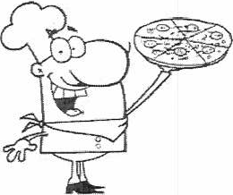Olivia ate 1/4 of a cheese pizza, 3/8 of a pepperoni pizza and 1/2 of a

mushroom pizza.
- Sergio ate 5/8 of a cheese pizza and the other 1/2 of the mushroom pizza.

- All of the pizzas were the same size.

- Using equivalent fractions, what are two ways Olivia can represent 1/4 of a cheese pizza?

- In total, how much cheese pizza did Olivia and Sergio eat?

- Olivia says she ate more pizza that Sergio because Sergio did not eat any pepperoni pizza. Sergio says they ate the same amount of pizza.
Who is correct? Justify your answer.

