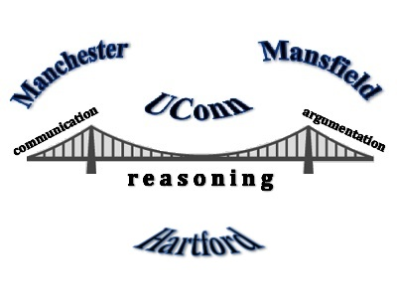

June, 2015
Dear Bridging Math Practices Participant!

We are very excited to have you back as part of the Bridging Practices across Connecticut Mathematics Educators Mathematics and Science Partnership Grant! We will again have teachers coming together from three districts – Hartford, Mansfield, and Manchester – and are looking forward to our continued collaboration. Once again, we will meet in the Gentry Building, room 144 on the Storrs Campus. We will meet Wednesday, June 24th and Thursday, June 25th from 8:30-a.m. – 4:30 p.m. and Friday, June 26th from 8:30 a.m. – 2:30 p.m.

This summer our work will be organized around the following goals: 1) continue to deepen understanding of proportional and algebraic reasoning and mathematical argumentation across grade levels; 2) support individual and team work in the revision and refinement of the curricular and pedagogical tools created and implemented over the past academic year for supporting students' mathematical argumentation; 3) support team work to create “resource packets” to be shared across schools and districts; and 4) to facilitate individual and school-wide work on academic year plans for implementing and assessing curricular and instructional tools and on dissemination of the yearlong work at school sites and districts. There will also be opportunities to work on reviewing classroom video clips and online modules being developed to support pre- and in-service teacher learning.

A few other details may be helpful. You will be compensated $25 per hour just like last summer. Compensation will be processed after completion of the workshops, and will take a few weeks. Unlike last year, the final math assessment will be embedded into the last day of the June PD. Lunches are provided, as is morning coffee. Lunches will be “working lunches” as they are supported by the grant. We want to thank Dr. Tom DeFranco – math educator and former dean – for his generosity in providing this!

Finally, on Wednesday, our evaluator will be conducting a Focus Group during lunch time. We will be inviting some of you to participate – aiming to get representation from across districts, schools and grade levels. Parking is also provided.

If you have any questions please do not hesitate to contact Dorothea Anagnostopoulos at dorothea.anagnostopoulos@uconn.edu. We are looking forward to seeing you soon!

What to Bring to the Workshop

- Many of you have shared classroom sets of student work already. If you have not done so, or if you have more you would like to share, please bring it.

- Please bring a laptop or tablet device. If you are unable to do so, let us know and we will try to provide one for you. Having a device will facilitate our summer work. We will try to have ample powercords to keep you charged up!

- Layering with a sweater or sweatshirt is encouraged. With summer time and AC, the rooms we will be working fluctuate some in temperature and sometimes are on the colder side.

Current Parking Information
This information is also on the website.
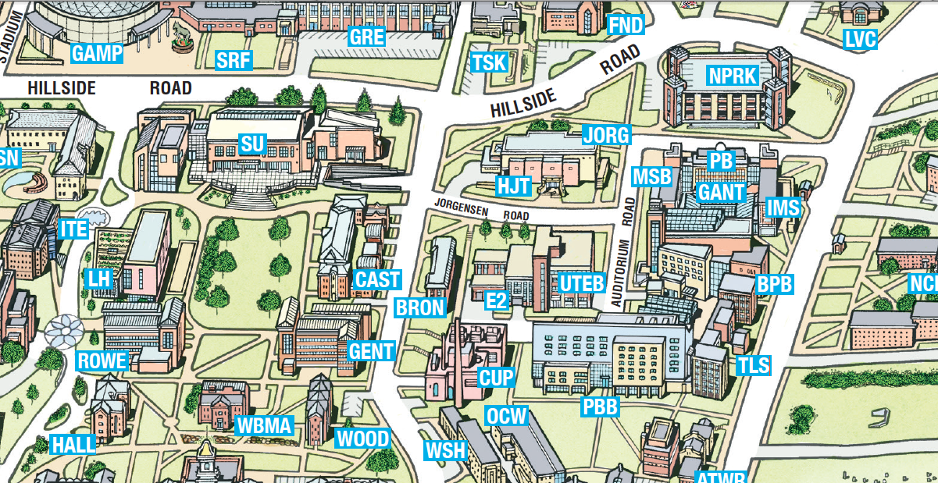
North Parking Garage

North Eagleville Road

Parking for All Visitors:
North Parking Garage (NPRK)
103 North Eagleville Road, Storrs, CT 06269

Parking will be validated. Please bring your ticket in each day, and get it stamped on your arrival. Present the ticket as you leave the garage.

Walking Directions to Gentry (GENT) from North Parking Garage (NPRK) (highlighted in red on the map)
Walk straight out of the North Garage towards campus.
Walk by Jorgensen Center for the Performing Arts (JORG) (the theater).
Veer left down Glenbrook Road (first road after Jorgensen Center for the Performing Arts).
Walk down Glenbrook Road until you see the Gentry building (it will be the second building on your right).
Enter and proceed up the flight of stairs. We’re on the main floor in the large glassed in room on your right.

